

2024



|  |  |  |
| --- | --- | --- |
| **Supervisor** | **Balsan Adam** | |
| Batch | PR2-202310E | |
| Group | A | |
| Serial No. | Enrollment Number | Students Names |
| 1. | Student#1515495 | Balsan Adam |
| 2. | Student#1512422 | Maimoona |
| 3. | Student#1511161 | Javeria Nadeem |

# Certificate of Completion

This is to certify that **Balsan Adam, Maimoona, Javeria Nadeem** have successfully completed their ACCP Prime 2.0

Semester I E-Project.

Submitted to: **Aptech Computer Education**

On February 19th, 2024

Acknowledgement

First of all we would like to thank **Almighty Allah** for giving us strength and ability to complete this project.

And then, we would like to express my special thanks of gratitude to our teacher **Sir Mansoor Ahmed** who guided us on the project ***OceanGate,*** which also helped us in doing a lot of new learning and we came to know about so many new things we are really thankful to him.

We are highly thankful to **Sir Mansoor Ahmed** for his guidance and constant supervision as well as for his support in completing the project.

Lastly, we would also like to thank our parents and friends who helped us a lot in finalizing this project within the limited time frame. We also express our sincere gratitude to I-Project team from Aptech Head Office, for their valuable guidance and support for the completion of this project. We earnestly hope that this project will provide all the necessary information required by the user to fulfill his/her inspiration. However, suggestion and Feedbacks for improvements will be thankfully welcomed & acknowledged*.*

**Problems Statement:**

**OceanGate** Limited is a company established 3 years back which deals in various data storage products right from floppy disk to optical storage devices. It has state of the Art machinery for production of the storage devices/disks which are becoming popular as days pass by due to the excellent quality, fast delivery on purchases and efficient after sales Services.

**OceanGate** products have become so popular that the demand for the products is not only coming from local market but also international market.

# Functional Specification

The Web site is to be created based on the following requirements.

1. The Home Page should be created with proper sections, graphics and with a suitable logo
2. The site should display a menu which will contain the options for brief introduction about the various products available, location of the shop and any other information if required.
3. The information should be categorized according to the brand names of the products like if a User wants to see only Samsung products then he click on a Link/button/menu etc. and he will see only That Brand products.
4. When a user selects any particular brand, a list of products for that brand will be displayed
5. A brief summary of features of individual products should be displayed on the Web Page along with the product but detailed Features should be storein Individual Word documents which can be downloaded or viewed by the User who wishes to see the same.
6. The user should also be able to compare the various products of different as well as similar brands.
7. There should be a “Contact Us” page which will have the Address of the Company which is as follows and the mail address which when clicked will invoke the local mail client from where they can send an email.

# Hardware and Software Requirements

Hardware

* A minimum computer system that will help you access all the tools in the courses is a Pentium 166 or better
* 64 Megabytes of RAM or better

**Software**

* Notepad/HTML editor/Coffee Cup
* Angular / Angular JS / React / Bootstrap
* Dreamweaver / Figma
* MS IE / Chrome / Firefox / Netscape /MS Edge

**Project Synopsis**

OceanGate is embarking on a strategic initiative to revamp its storage solution offerings, encompassing SSDs, hard disks, and modernized floppy disks. This project aims to leverage cutting-edge technology to enhance product performance, reliability, and environmental sustainability. The initiative will focus on integrating innovative materials and processes to meet the growing demand for efficient, high-capacity storage solutions across various sectors, including IT, gaming, and data centers.

# **Website Features**

**OceanGate's** website is a hub for showcasing its cutting-edge storage devices, including SSDs, hard disks, and floppy disks. With an intuitive product catalog that offers detailed specifications and high-resolution images, users can effortlessly explore OceanGate's offerings. Education and customer support are central to the website, featuring a wealth of educational resources, and a comprehensive FAQ section to assist users with their inquiries. OceanGate also highlights its commitment to eco-friendly manufacturing processes, demonstrating the brand's dedication to sustainability. With multilingual support, OceanGate ensures that users from around the globe can access information and engage with the brand, further emphasizing its focus on quality, innovation, and customer satisfaction in the digital storage space.

USER’S **GUIDE**

HOME PAGE:

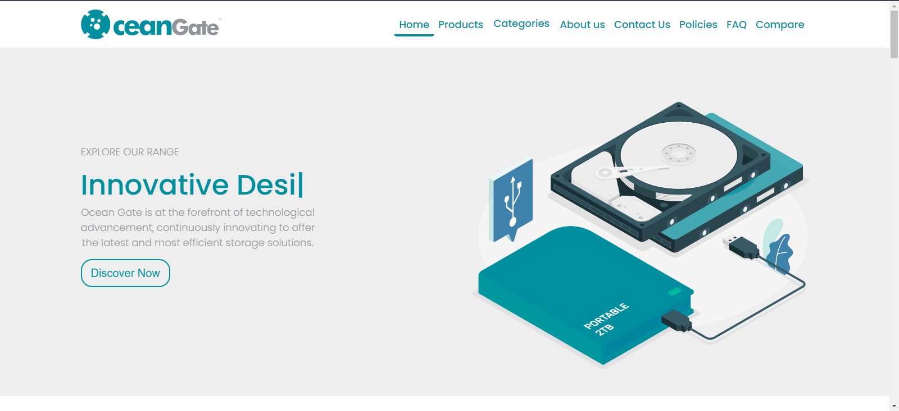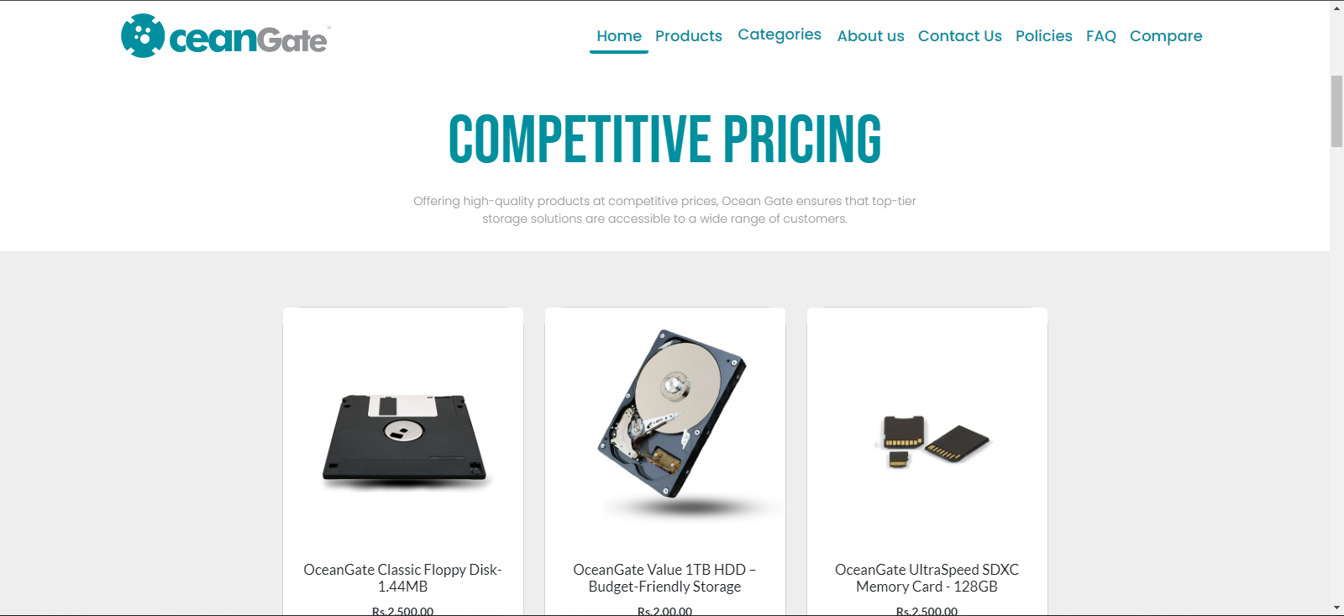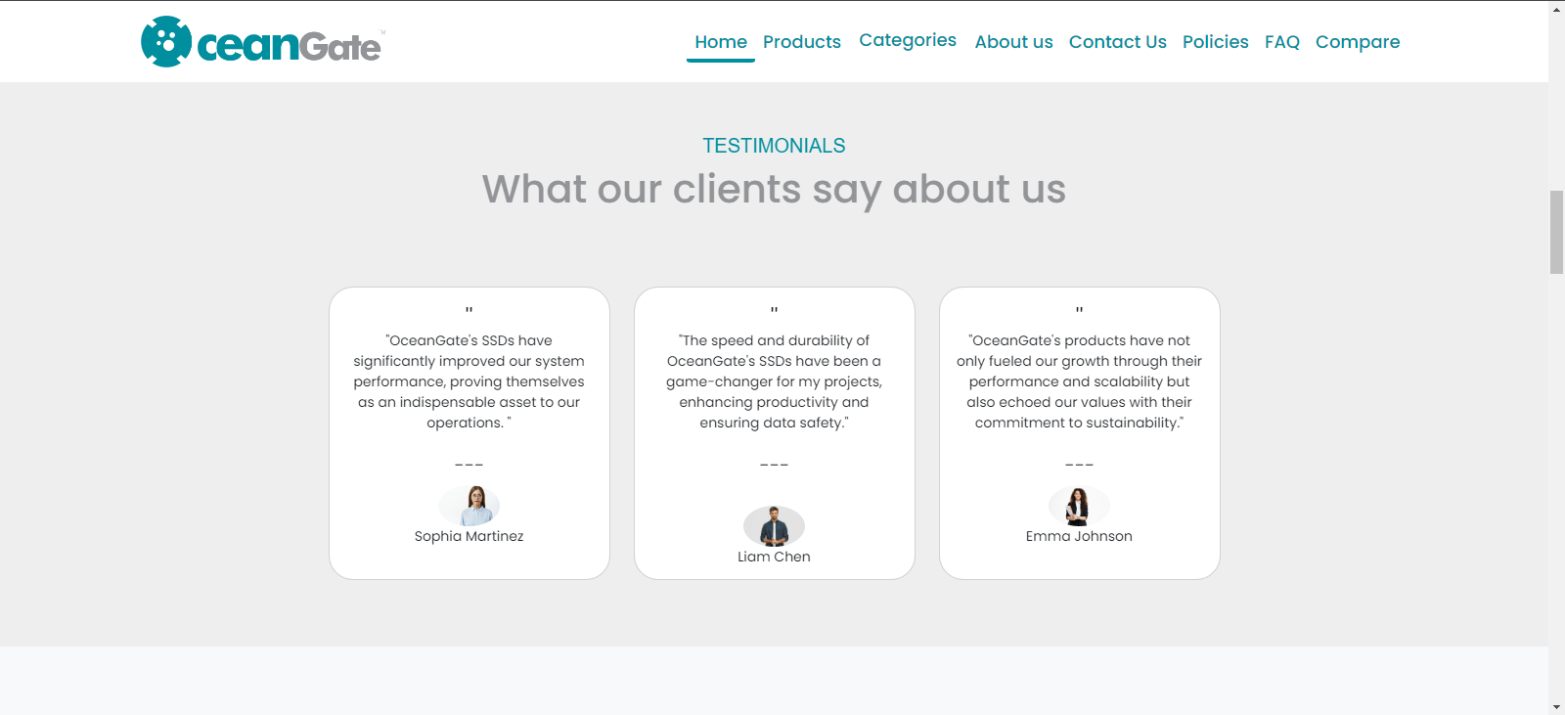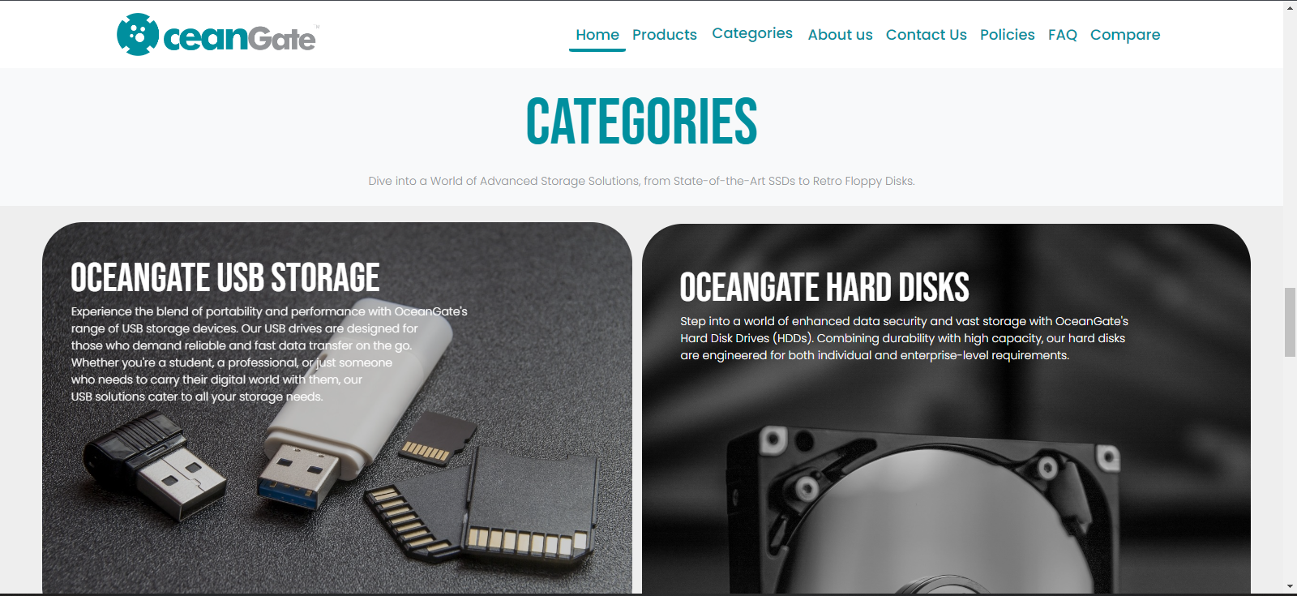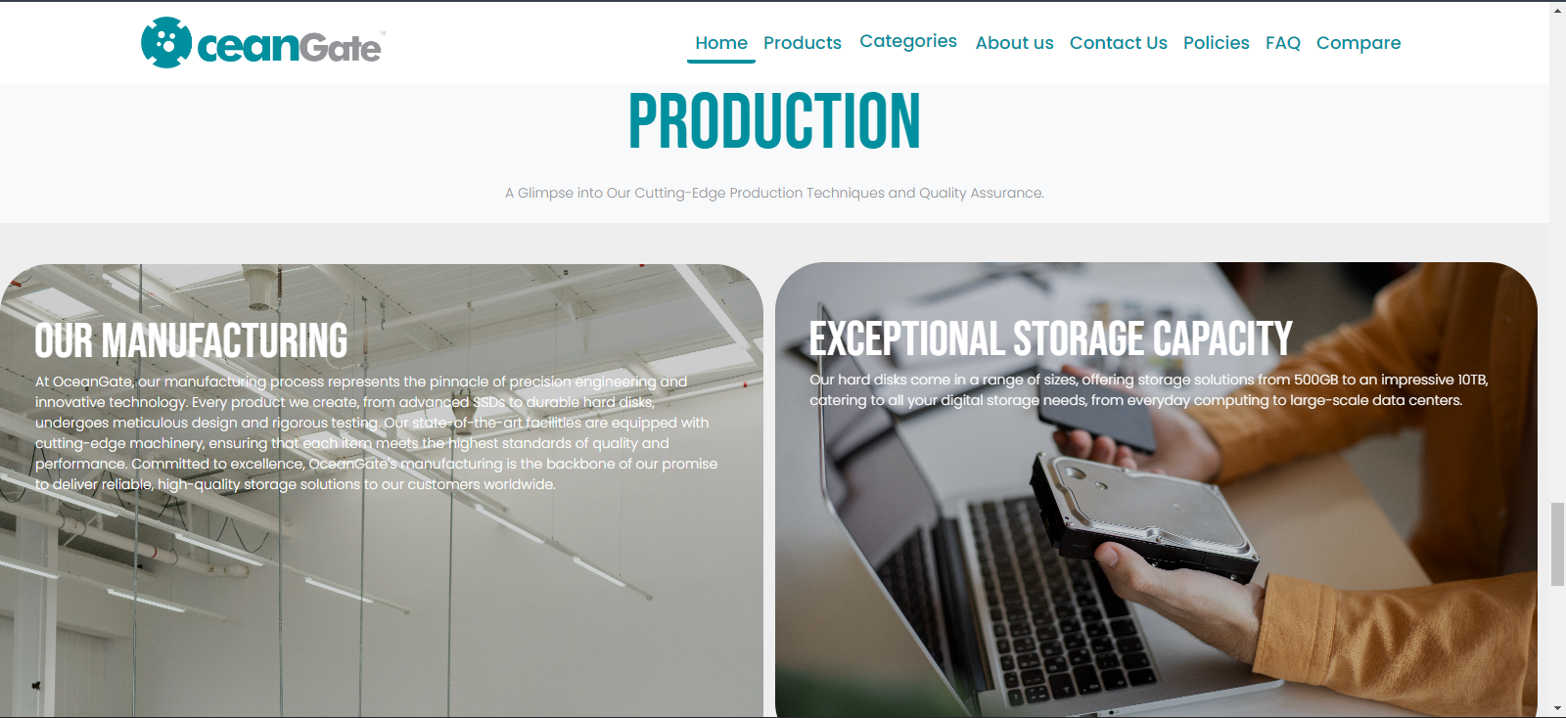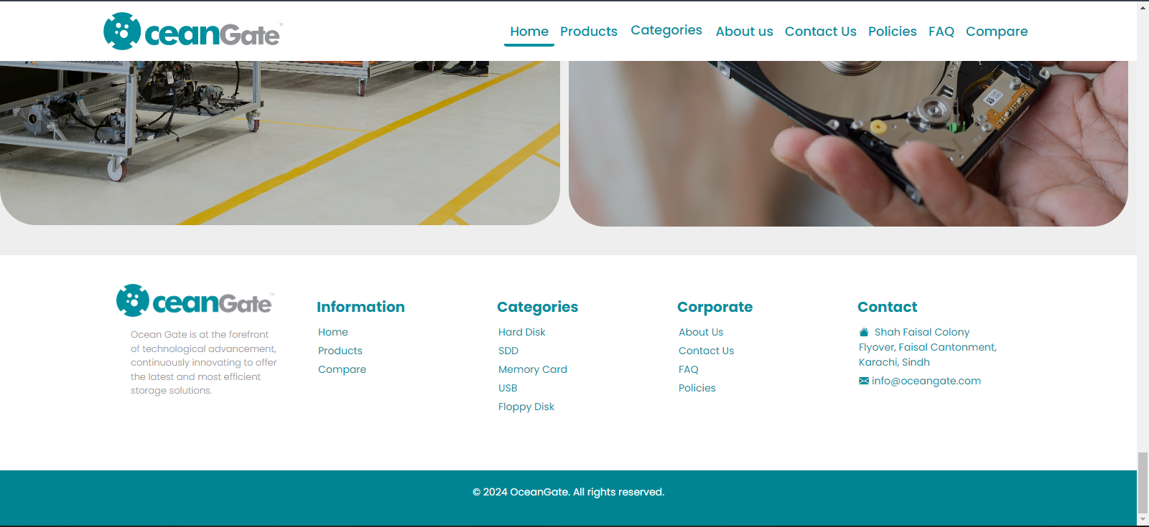

ABOUT US:

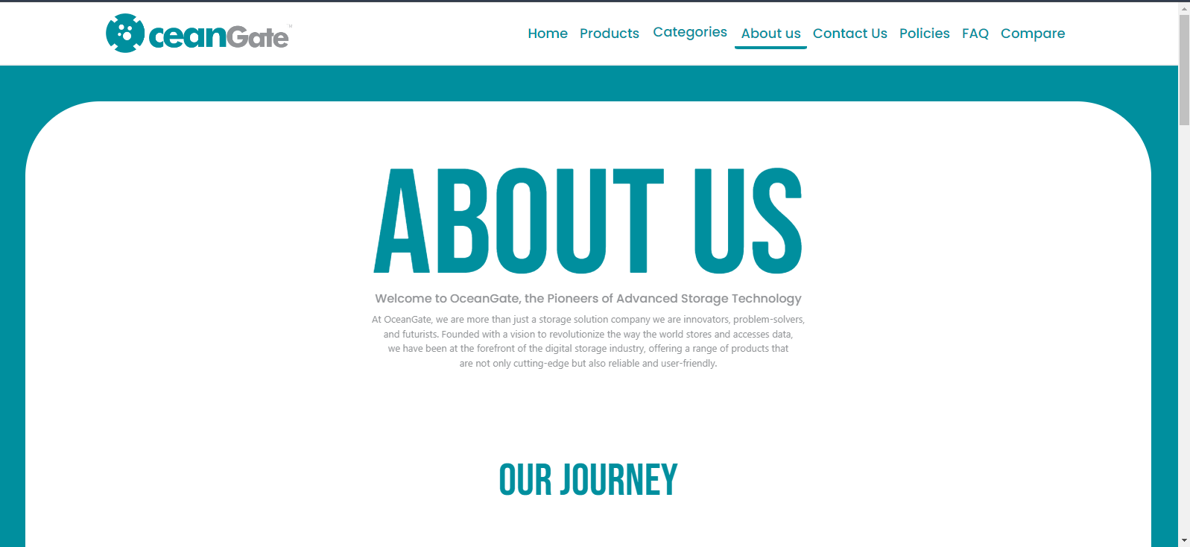

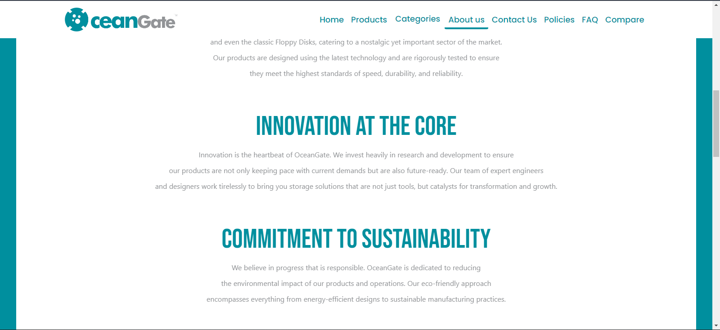

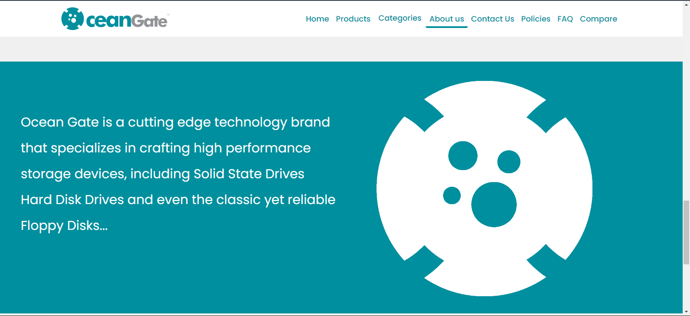

Ocean Gate Products:

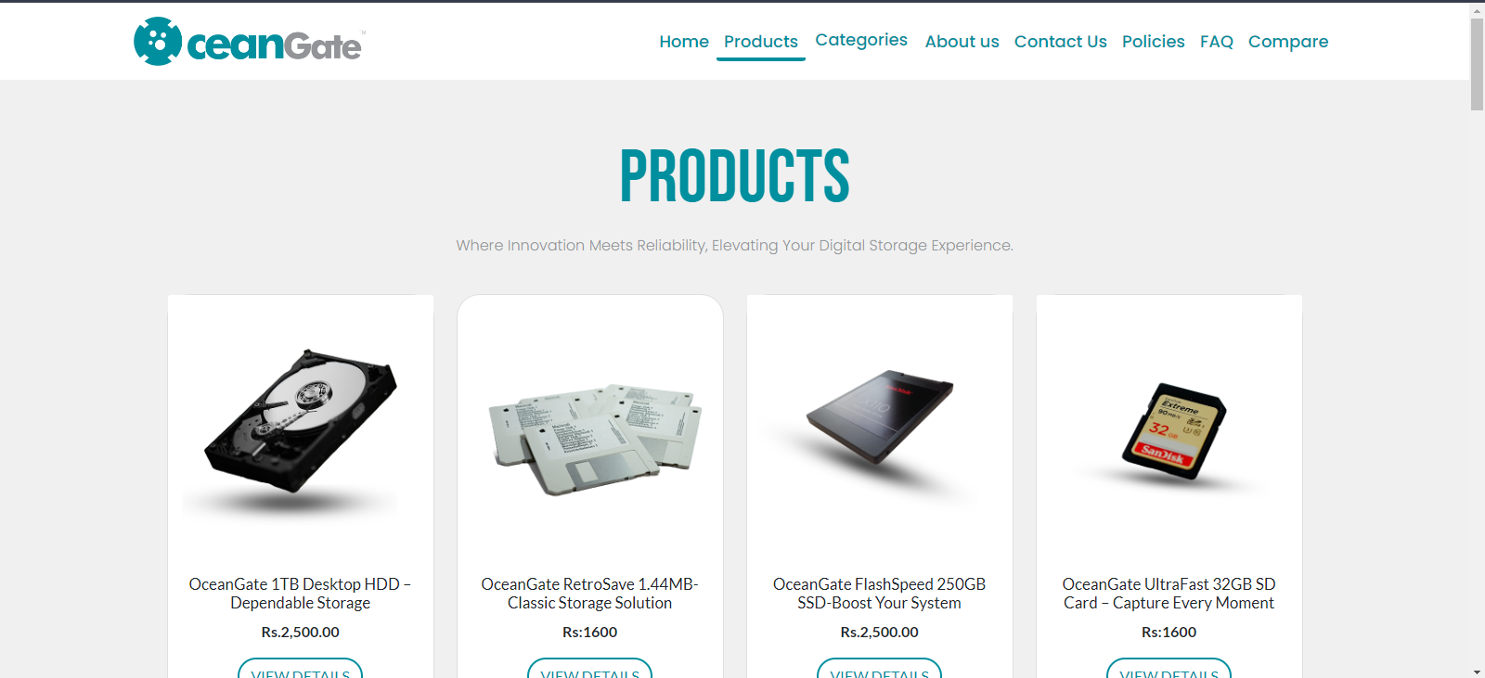

CONTACT US:

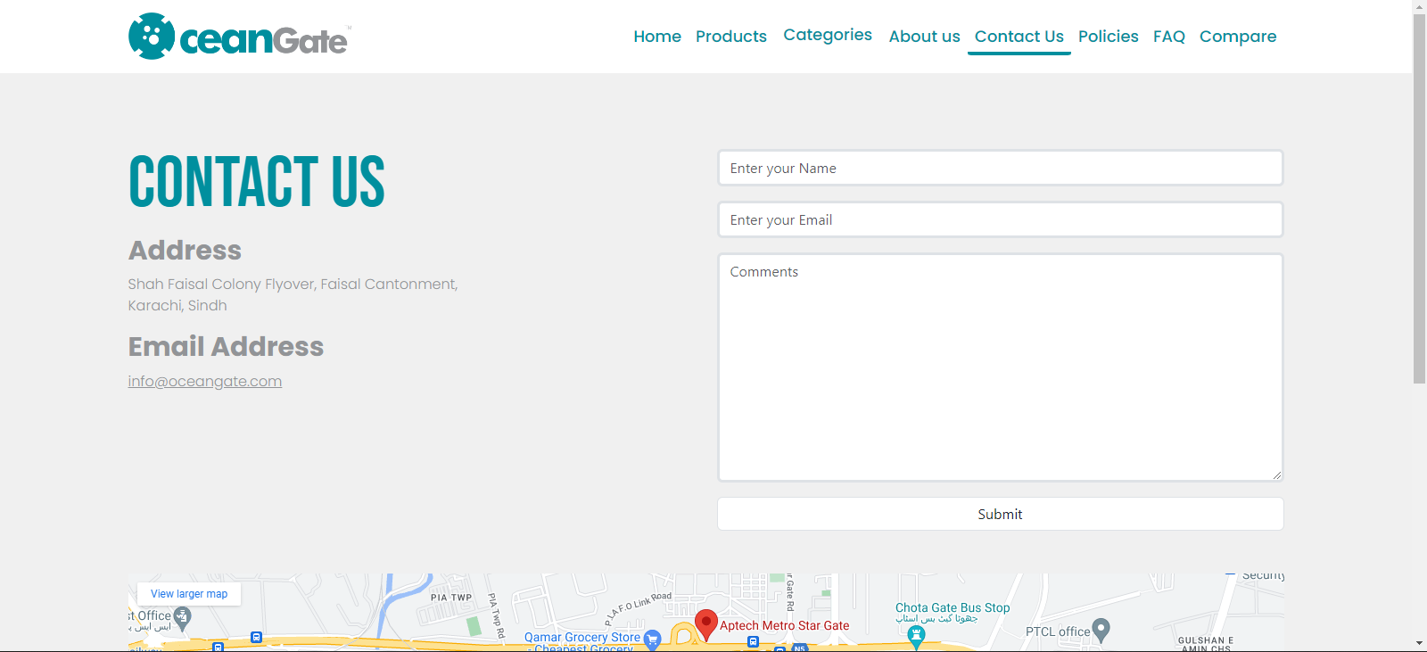

FAQ’S:

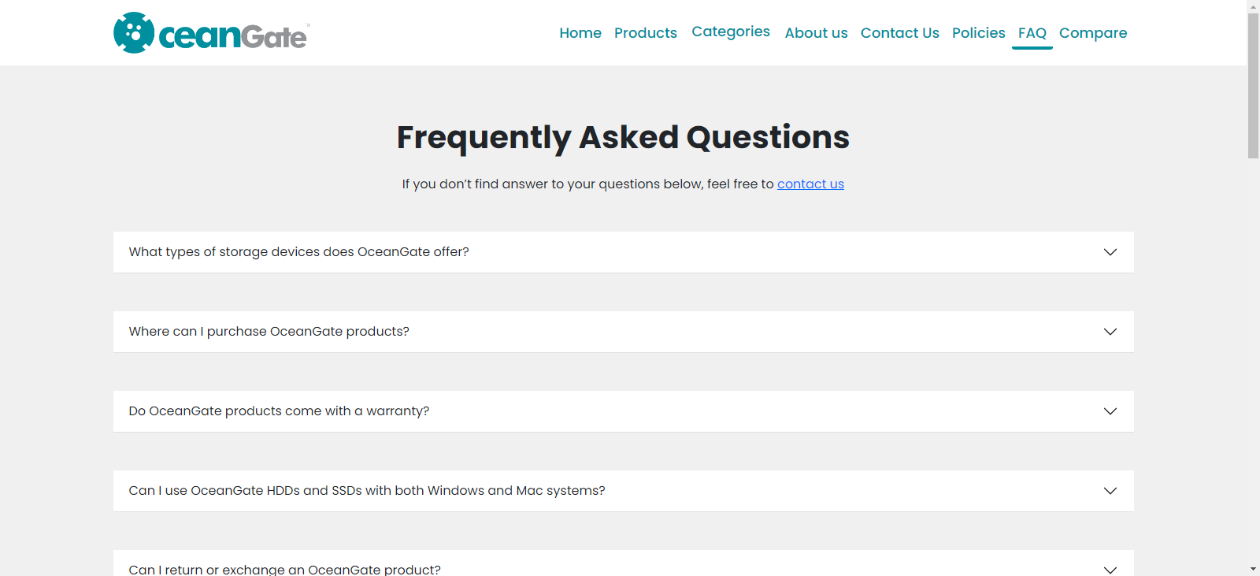

CATEGORIES OF OCEANGATE

Hard Disks:

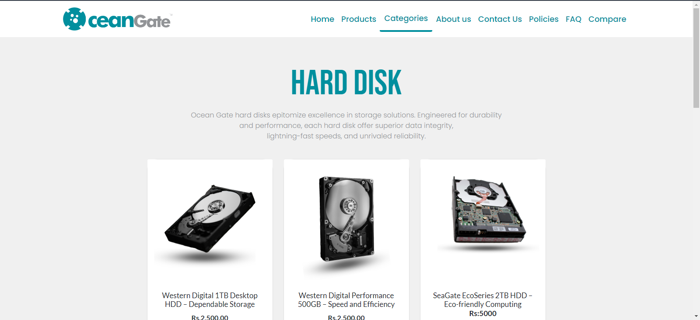

Western Digital Hard Disk:

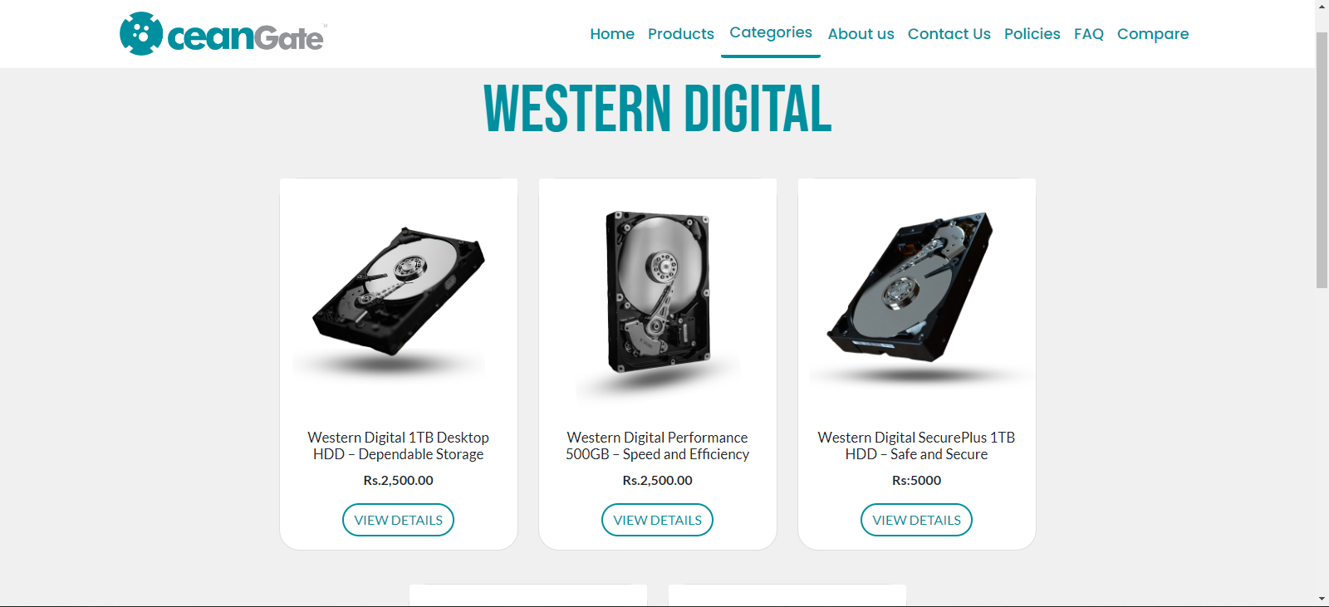

Seagate’s Hard Disks:

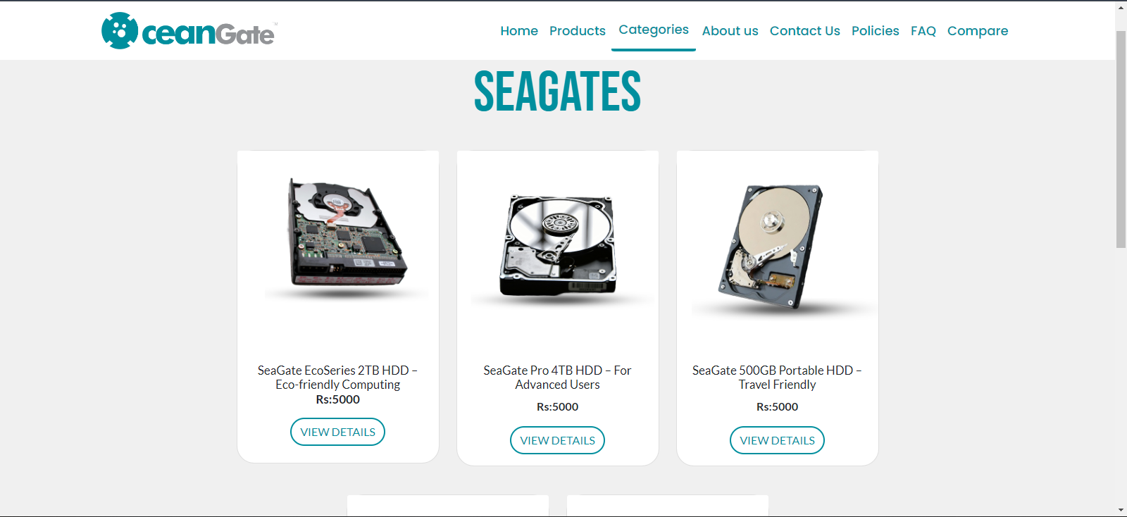

SSD (Solid State Drives):

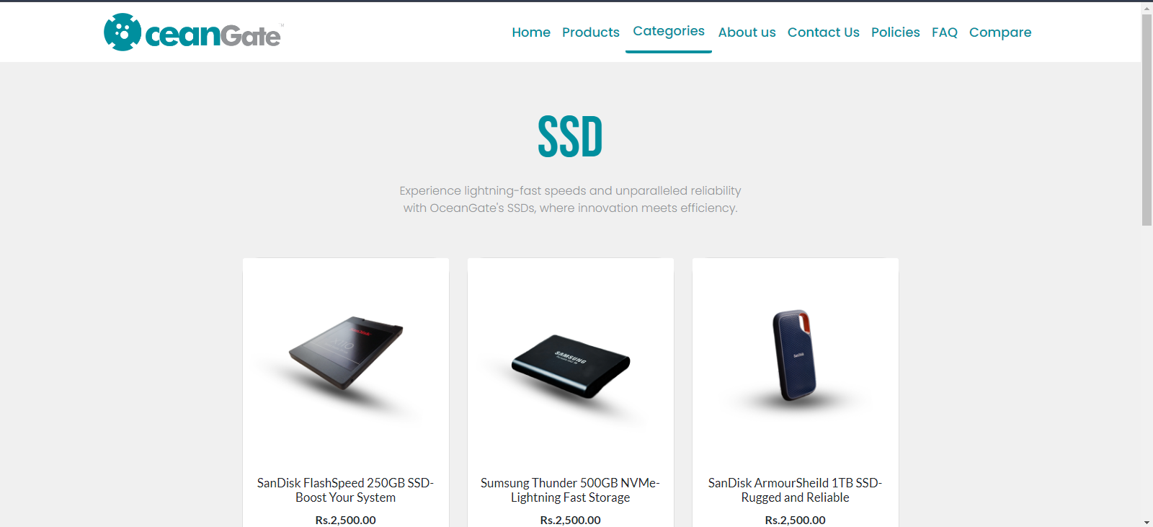

Samsung SSD:

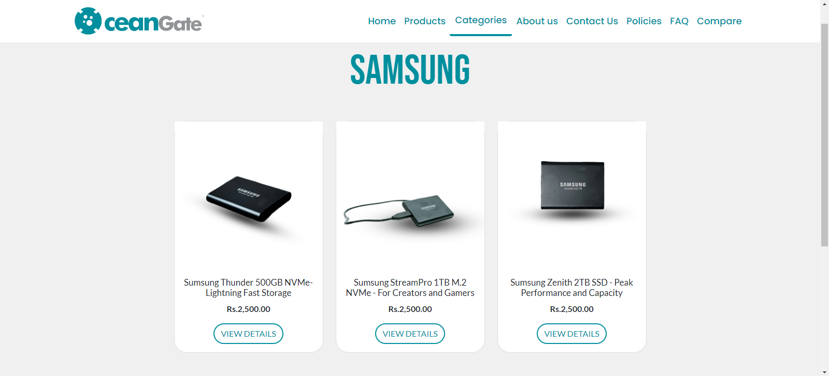

SanDisk SSD:

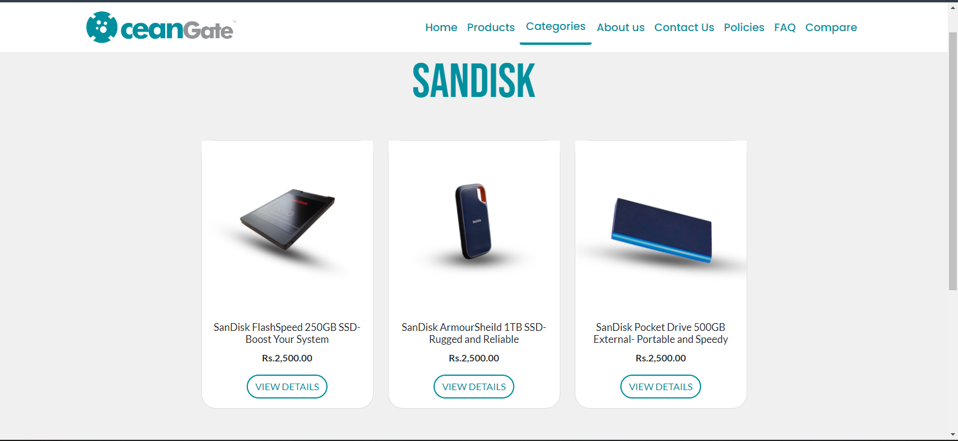

USB:

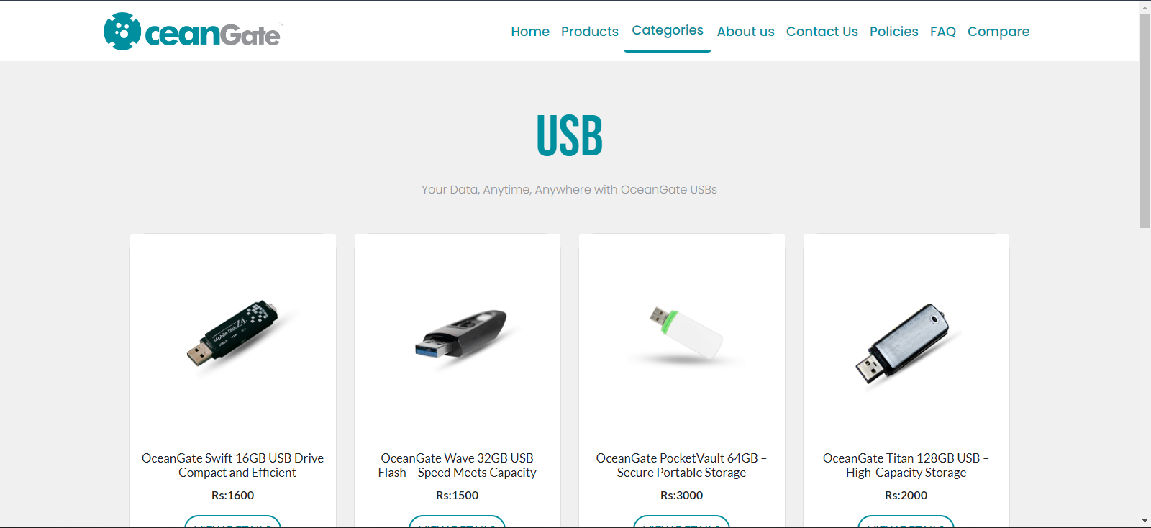

Memory Cards:

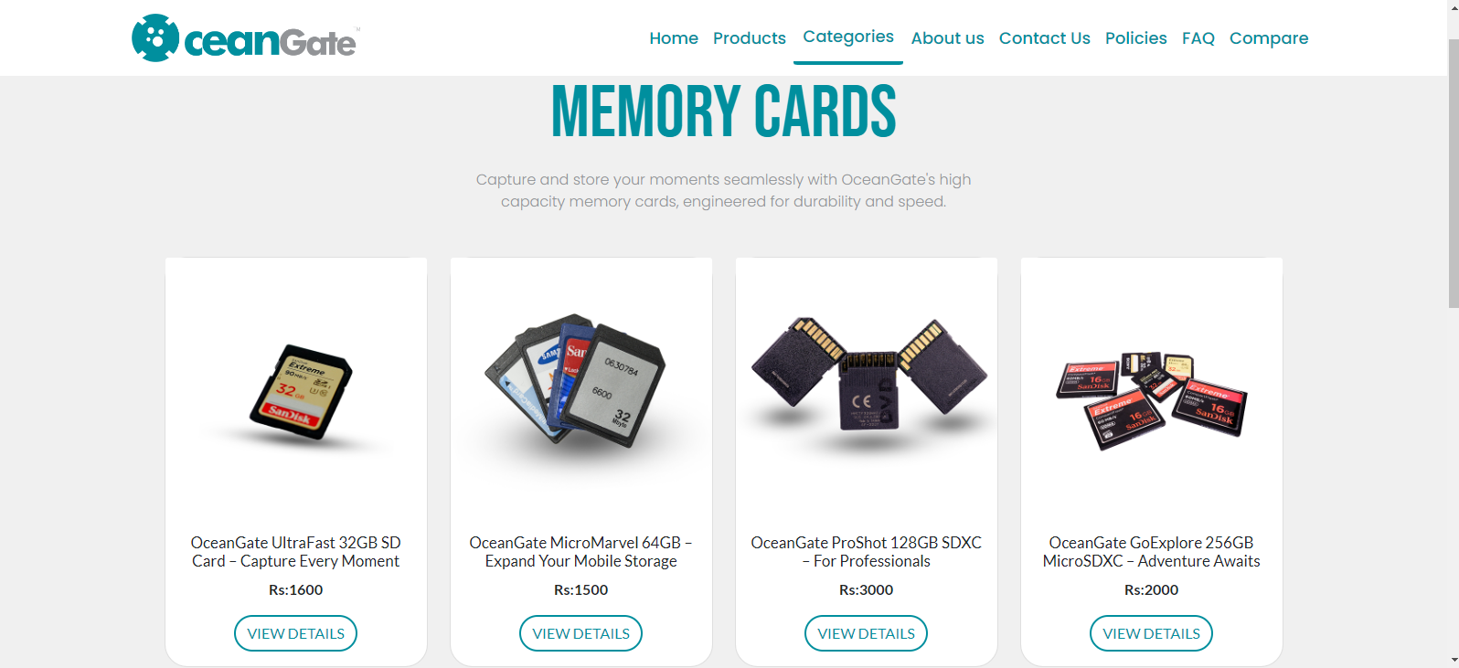

Floppy Disks:

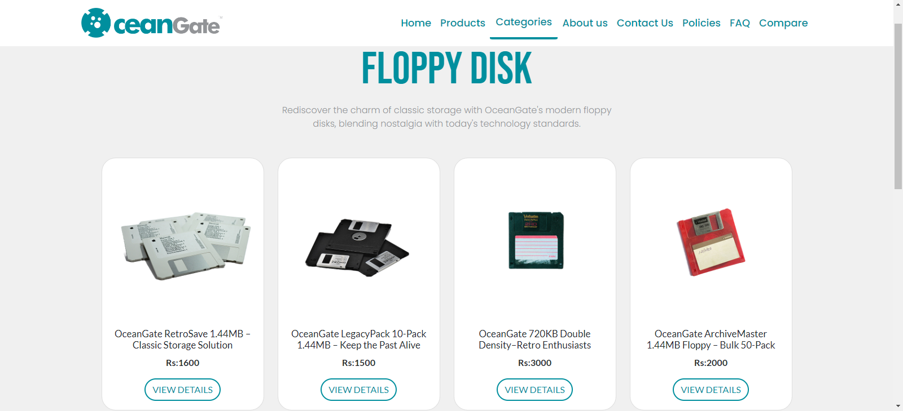

OceanGate Privacy Policy Page:

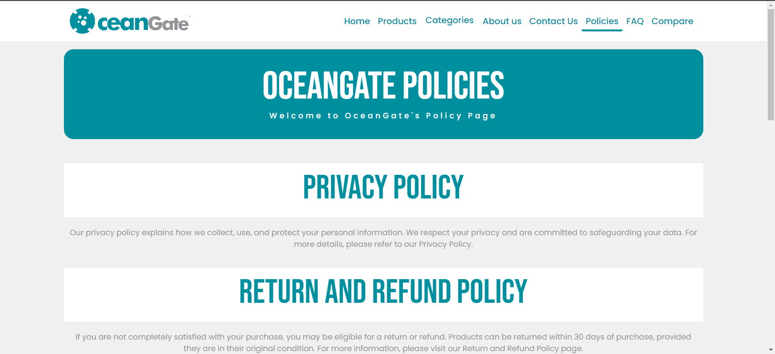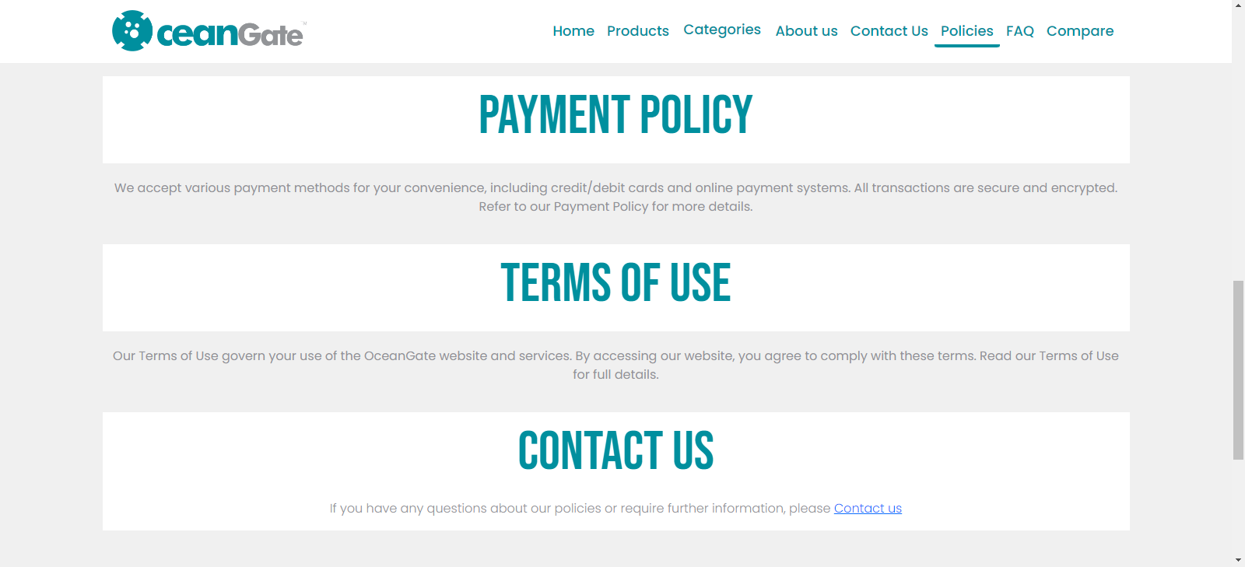

Product Compare Page:

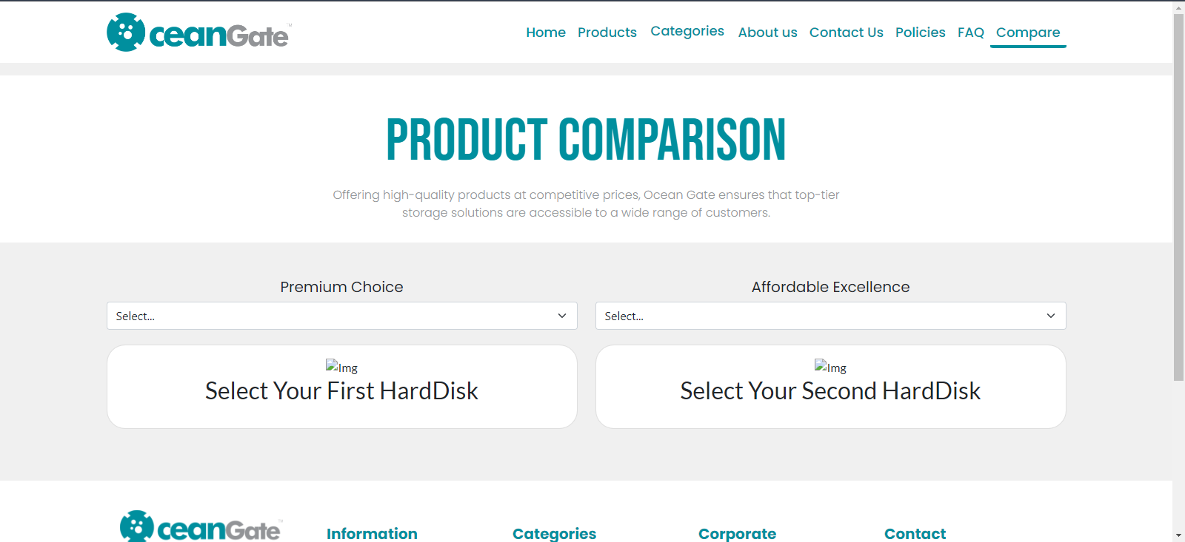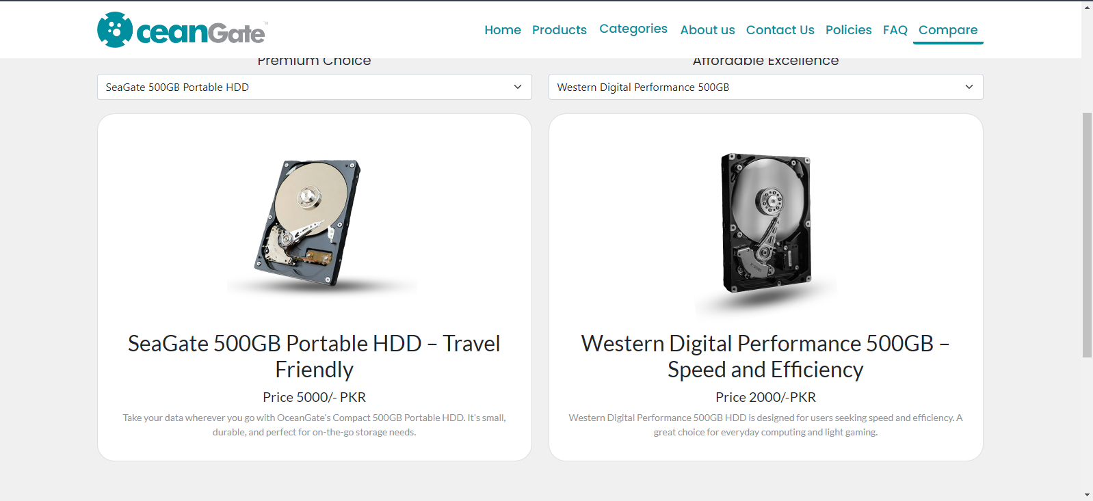

DEVELOPER’S GUIDE

Homepage:

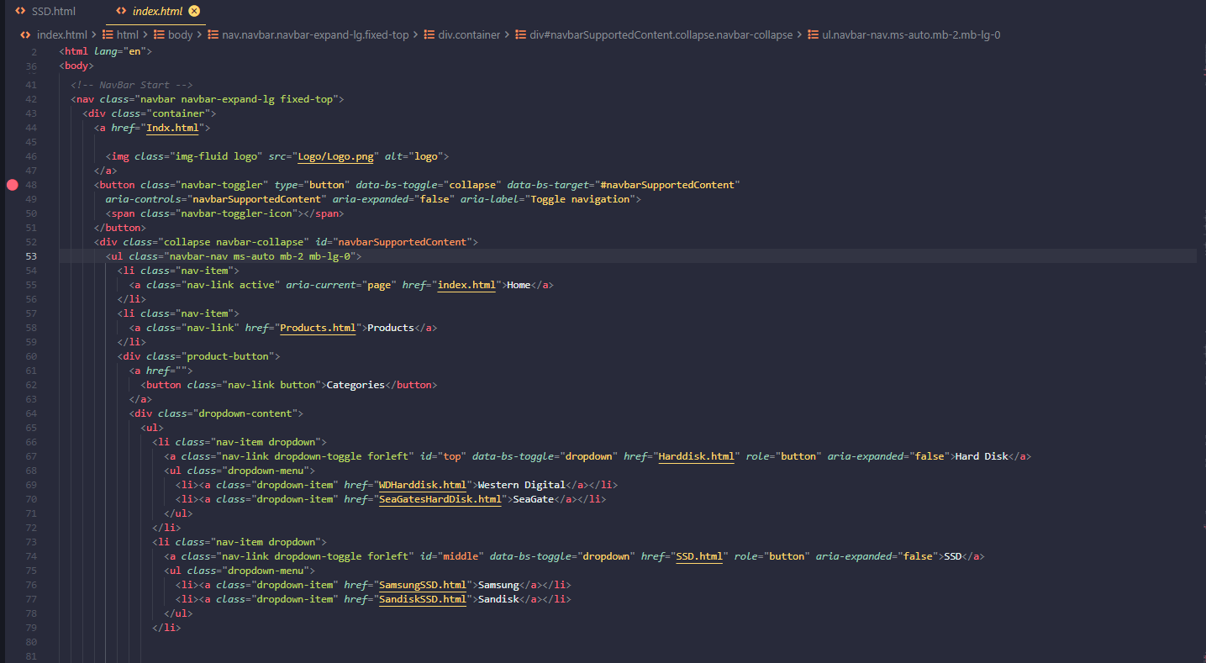

Banner:

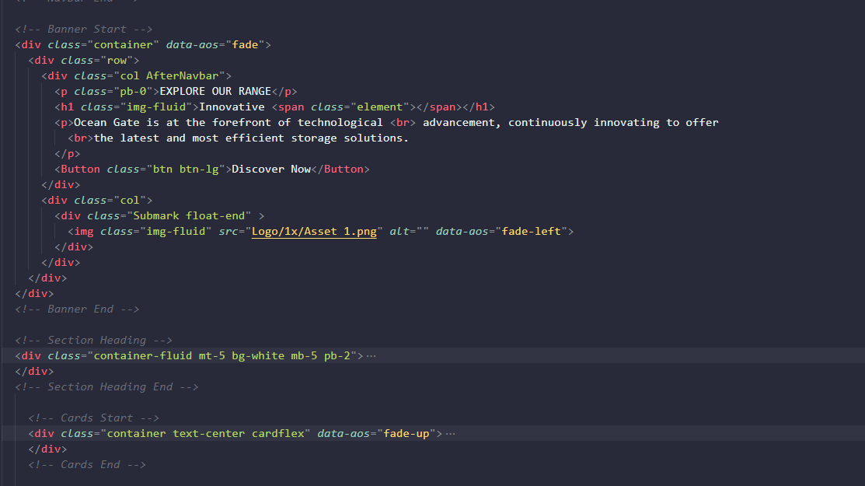

Footer:

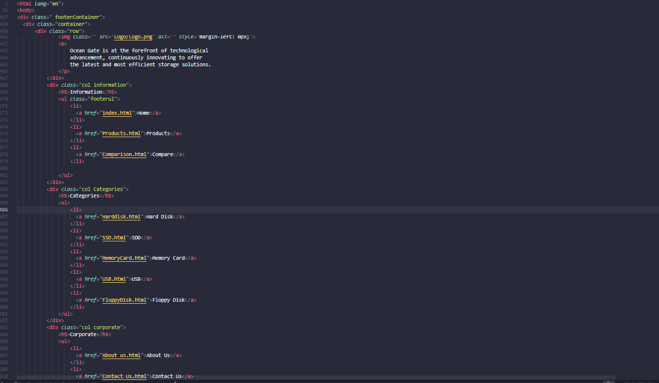

Task Sheet

|  |  |  |  |  |
| --- | --- | --- | --- | --- |
| *Project Ref. No.* | | *Project Title* | *Date of Preparation of Activity Plan* | |
| *S.No.* | Ta | **OCeanGate** | Actual Days | Status |
| *1* | Analysis | 2 | OK |
| *2* | Design | 6 | OK |
| *3* | Development | 6 | OK |
| *4* | Testing | 1 | OK |
| *5* | Documentation | 1 | OK |